horizontal line

Project Summary

|  |  |
| --- | --- |
| Batch details | DSE – JULY 2022 |
| Team members | Narashimmhan R S  Jeeva Anand B  Swetha R Ve  Muthurampandian R  Nandakumar A K |
| Domain of Project | Sales Anlaytics |
| Proposed project title | Unlocking Sales Potential in Lowa Liquor through Data Analytics |
| Group Number | Team 04 |
| Team Leader | Swetha R Ve |
| Mentor Name | Pratik Sonar |

Date:

Signature of the Mentor Signature of the Team Leader

Table of Contents

|  |  |  |
| --- | --- | --- |
| Sl NO | Topic | Page No |
| 1 | Overview | 3 |
| 2 | Business problem goals | 3 |
| 3 | Topic survey in depth | 4 |
| 4 | Critical assessment of topic survey | 5 |
| 5 | Methodology to be followed | 6 |
| 6 | References | 7 |

Project Details

# OVERVIEW

The Lowa Liquor Sales Analytics is a data-driven approach to analyzing sales data of liquor products in Iowa in order to identify patterns and trends that can be used to optimize sales and increase revenue. The goal of the analytics is to understand the factors that impact the sales of liquor products in Iowa, identify the popular and declining product categories and regions, and provide insights into customer behavior and preferences.

The analytics approach involves collecting and cleaning sales data to ensure accuracy and completeness. The cleaned data is then analyzed using data visualization and statistical analysis techniques to identify trends in sales by product, region, and time period. The analysis also considers external factors such as holidays, weather, and economic conditions that may impact sales.

The analytics approach also involves identifying customer segments based on purchasing behavior, demographics, and other factors. This information is then used to develop targeted marketing campaigns and promotions that appeal to specific customer segments. A predictive analytics model is developed to forecast future sales based on historical trends and other factors. This model helps to inform inventory management decisions and ensure that the right products are stocked in the right quantities to meet demand.

Overall, the Lowa Liquor Sales Analytics provides businesses with valuable insights that can be used to optimize sales strategies and tactics. By leveraging these insights, businesses can increase revenue, reduce costs, and improve overall business performance.

# Business problem statement (GOALS)

**Business Problem Understanding**: Lowa Liquor is a retail store that specializes in selling various types of alcoholic beverages. The store has been facing a decline in sales over the past year, and the management team is concerned about the reasons behind this decline. The store wants to identify the factors that are contributing to the decline in sales and find ways to improve the sales performance.

**Business Objective:** The objective of the business is to identify the factors that are causing the decline in sales and develop strategies to increase sales revenue. The business wants to analyse sales data and customer behaviour to identify patterns and trends that can help them make informed decisions about how to improve their business operations.

**Approach:** To address the business problem, we will take the following approach:

1. **Collecting and analysing sales data:** We will gather sales data from Lowa Liquor for the past year, including sales revenue, sales volume, and sales by product category. We will analyse this data to identify trends and patterns that can help us understand the factors contributing to the decline in sales.
2. **Analysing customer behaviour:** We will also gather data on customer behaviour, including customer demographics, purchase history, and preferences. We will analyse this data to identify customer segments, their purchasing habits, and their preferences.
3. **Identifying opportunities for improvement:** Based on the analysis of sales data and customer behaviour, we will identify opportunities for improvement. This may include changes to the product mix, pricing strategies, promotions, or marketing efforts.
4. **Developing an action plan:** We will develop an action plan based on our analysis and recommendations. The action plan will include specific steps that the store can take to improve its sales performance.

**Conclusions:**

Based on our analysis, we will provide recommendations to Lowa Liquor to improve its sales performance. Our recommendations may include changes to the product mix, pricing strategies, promotions, or marketing efforts. We will also provide guidance on how to implement these recommendations and measure their effectiveness over time. Overall, our goal is to help Lowa Liquor improve its sales revenue and achieve its business objectives.

# TOPIC SURVEY IN BRIEF

**Problem understanding:** The problem is that Lowa Liquor, a retail store specializing in selling alcoholic beverages, has experienced a decline in sales over the past year. The management team is concerned about the reasons behind this decline and wants to identify the factors contributing to it.

**Current solution to the problem:** There is currently no specific solution in place to address the decline in sales at Lowa Liquor. The store may be implementing general strategies such as marketing and promotion campaigns, but there is no evidence that these strategies are effective.

**Proposed solution to the problem:** The proposed solution is to use data analysis and machine learning techniques to identify the factors contributing to the decline in sales and develop strategies to improve sales revenue. This may involve analyzing sales data and customer behavior, identifying patterns and trends, and using this information to make data-driven decisions about pricing, product mix, promotions, and inventory management.

**Reference to the problem:** The decline in sales at Lowa Liquor is a common problem faced by many retail businesses. Similar problems have been addressed in other industries by using data analysis and machine learning techniques to improve sales performance. References to this problem may include case studies, academic literature, or industry reports on retail sales performance.

# CRITICAL ASSESSMENT OF TOPIC SURVEY

Key areas and gaps identified in the topic survey where the project can add value to the customers and business:

**a) Data-driven decision making:** The project can add value by using data analysis and machine learning techniques to identify the factors contributing to the decline in sales and developing strategies to improve sales revenue. This can help Lowa Liquor make data-driven decisions about pricing, product mix, promotions, and inventory management, leading to increased sales and improved business performance.

**b) Customer segmentation and targeting:** By analysing customer behaviour, the project can identify different customer segments and their preferences, allowing Lowa Liquor to target specific customer groups with personalized promotions and product offerings. This can lead to increased customer satisfaction and loyalty.

**c) Optimal inventory management:** By analysing sales data and predicting demand, the project can help Lowa Liquor optimize its inventory management, reducing the risk of stockouts and overstocking. This can result in improved operational efficiency and reduced costs.

**Key gaps the project is trying to solve:**

The project is trying to solve the key gaps in Lowa Liquor's sales performance by identifying the factors contributing to the decline in sales and developing strategies to improve sales revenue. Specifically, the project aims to:

a) Identify customer segments and their preferences, allowing Lowa Liquor to target specific customer groups with personalized promotions and product offerings.

b) Analyse sales data to predict demand and optimize inventory management, reducing the risk of stockouts and overstocking.

c) Use data-driven decision making to develop pricing strategies, product mix, and promotions that can increase sales revenue and improve business performance.Top of Form

# METHODOLOGY TO BE FOLLOWED (Explain each step from 1-5)

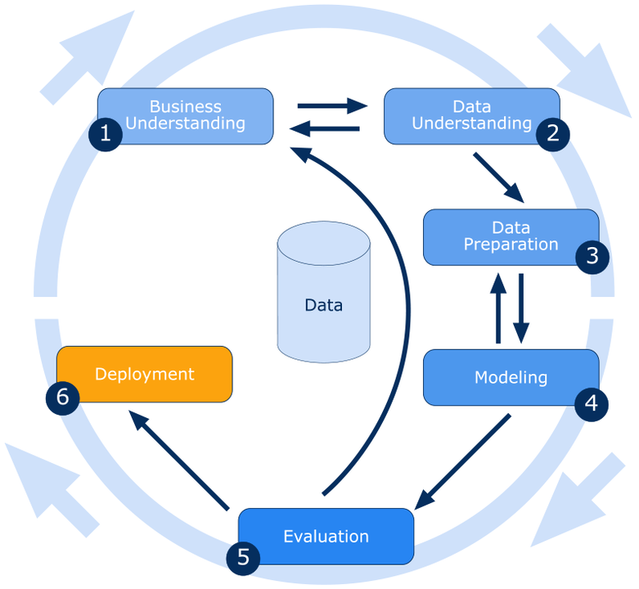

# *\* If deployment is out of scope to the team or not advised by the mentor, please opt to leave out the step no 6.*

**Business Understanding:**

The project will use a combination of descriptive and inferential statistics to analyze the sales data. The dataset will be cleaned and pre-processed to remove any missing or inconsistent data. Exploratory data analysis (EDA) techniques such as histograms, scatter plots, and box plots will be used to visualize the data and identify any outliers or anomalies.

The data will be segmented by various factors such as store location, brand, and category to identify patterns and trends. Statistical techniques such as regression analysis and time series forecasting will be used to predict future sales trends and identify any significant factors that affect sales. Finally, the results will be visualized using charts and graphs that are easy to understand and interpret. The insights will be communicated to the ABD and other stakeholders through a report or presentation.

**Data Understanding:**

Dataset consists of the historical data around the backorders. It has 23 features and 1687861 observations. Dataset can be found at: <https://www.kaggle.com/datasets/gabrielramos87/iowa-sales-liquor-jan-2021jan-2022>

**INDEPENDENT VARIABLES**

|  |  |
| --- | --- |
| **invoice_and_item_number** | Invoice number for the purchased product |
| **date** | Date of the product purchase |
| **store_number** | Product sold store number |
| **store_name** | Product sold store name |
| **address** | Product sold store address |
| **city** | Product sold store city |
| **zip_code** | Product sold store zip code |
| **store_location** | Product sold store location |
| **county_number** | Product sold country number |
| **County** | Product sold country |
| **Category** | Category number of Product sold |
| **category_name** | Category name of Product sold |
| **vendor_number** | Vendor number for the product distributed to the stores |
| **vendor_name** | Vendor name for the product |
| **item_number** | item number for the product |
| **item_description** | Description of the item sold |
| **Pack** | Number of bottles in a pack |
| **bottle_volume_ml** | Quantity per bottle |
| **state_bottle_cost** | Cost of the bottle state wise (whole sale) |
| **state_bottle_retail** | Cost of the bottle retail |
| **bottles_sold** | Number bottle bought |
| **sale_dollars** | Price in dollar |
| **volume_sold_liters** | Quantity sold in liters |

**Expected Outcomes:**

**The expected outcomes of this project are:**

Identification of patterns and trends in liquor sales in Iowa, such as seasonality, popular brands, and categories.

Prediction of future sales trends using statistical techniques such as regression analysis and time series forecasting.

Identification of factors that affect liquor sales in Iowa, such as demographics, competition, and marketing strategies, and recommendations to improve sales.

Visualization of data in a way that is easy to understand and communicate the insights to the stakeholders.

# *Reference documents of CRISP-DM*

1. <https://paginas.fe.up.pt/~ec/files_0405/slides/02%20CRISP.pdf>
2. https://en.wikipedia.org/wiki/Cross-industry_standard_process_for_data_mining

# REFERENCES

The references can be blogs, articles or even social media news relevant to explain the importance of the projects.

**Notes For Project Team**

*Sample Reference for Datasets (to be filled by team and mentor)*

|  |  |
| --- | --- |
| Original owner of data | Lowa Liquor sales |
| Data set information | Liquor sales details |
| Any past relevant articles using the dataset | - |
| Reference | Kaggle |
| Link to web page | - |

### 

***********************************************************